# SDG 4 - FIRST STEPS

## Project identity

Name,logo Tagline

FIRST STEPS

A learning aid for the English Alphabet to promote independent learning

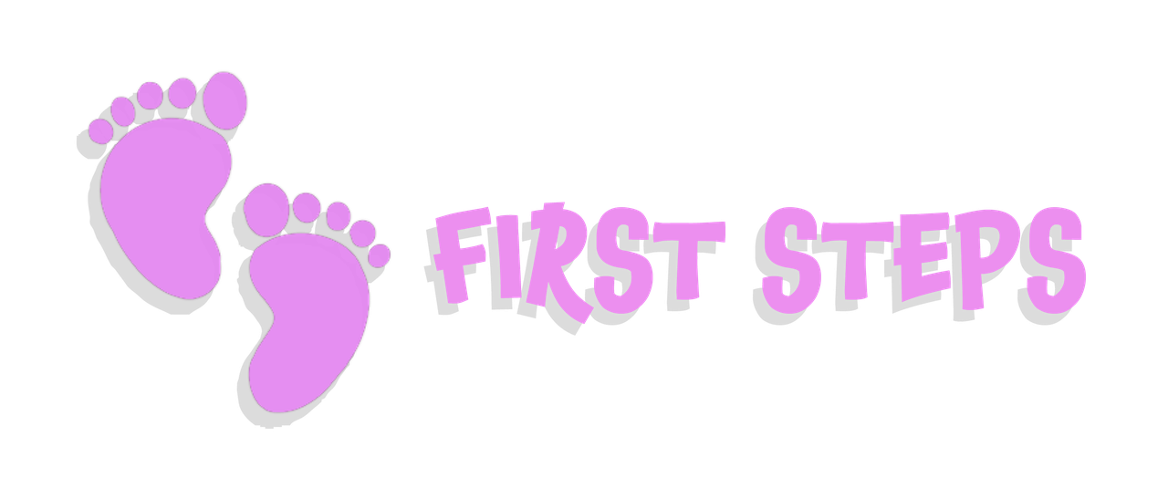

## Team members

Pictures, key skills and team roles

All four of us come from differnt backgrounds, differnt skills and interests with a common passion for the Education field

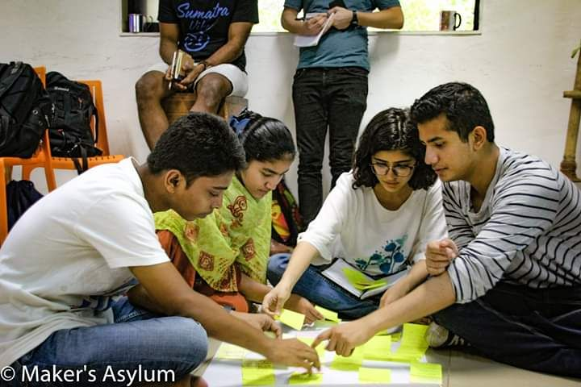

In Order (LtoR)

Anas- BA student, interests include studying ,volunteering to teach at Dharavi Diary, giving tours of Dharavi to visitors

Zaberi- BA student, interests include studying and volunteering at Dharavi Diary, Embroidery work, learning French

Nitya-Product Design student, interests include sketching, creative problem solving, experimenting with different materials

Amogh-Product Design Student, interests include programming,generative art, 3D modelling, design.

## Introduction

Project summary

We wanted to tackle the problem of learning of the English language at its root, where it starts which when the kids start to learn the alphabet which is a requirement to get admission to school at the primary level, we wanted to give them a strong base so that they don't face problems in the higher classes.

We made a learning aid that supplements the teaching of the alphabet. It is a toy that kids can play with and when they make a letter, the toy will light up and make the sound of the letter(at this stage we have not added the speaker yet) this toy enables the kids to learn the alphabet independently while playing. And this is such a toy that the kids will not be afraid of making a mistake but be encouraged to play around, explore the different shapes he/she can make and discover the letters along the way

## Process and motivation

How did the project come to life? How does it match your skills and motivation?

When we were discussing the topic of quality education in the schools in Dharavi, Zaberi and Anas shared that they found it difficult to cope up with the curriculum in college and study independently. Zaberi shared that the first three months in her college was a struggle, she had difficulty understanding the chapters being taught in the English language, she had trouble making friends as everyone there spoke mostly in English and she was afraid of the teachers, since then she has settled in but it is a continuous challenge to study independently.

## Statistical data

User persona,  data collection

## Prototypes

Documentation divided by iterations (Pictures / code / drawings / text)

Prototype #1

* 1. hypothesis
  2. experiment
  3. results / learning

We made cuts on one side of the paper roll to make it a flexible tube that could be used to form the letters of the alphabet

Prototype #2

* 1. hypothesis
  2. experiment
  3. results / learning

We tried to make the product with the strings that were made from the combination of metal wire and fur so that it could retain shapes while being flexible

Prototype #3

* 1. hypothesis
  2. experiment
  3. results / learning

We tried to 3D print a flexible product but the print turned out to be quite rigid

Prototype #4

* 1. hypothesis
  2. experiment
  3. results / learning

we went back to the idea of cuts like in the paper prototype but since we were using a rigid bamboo material we increased the space between the cuts and used the metal and fur strings to give flexiblity while retaining shape at the joints.

## Field study

Testing the project/service with users in a specific community

## Final product/service results

Pictures / and text summary

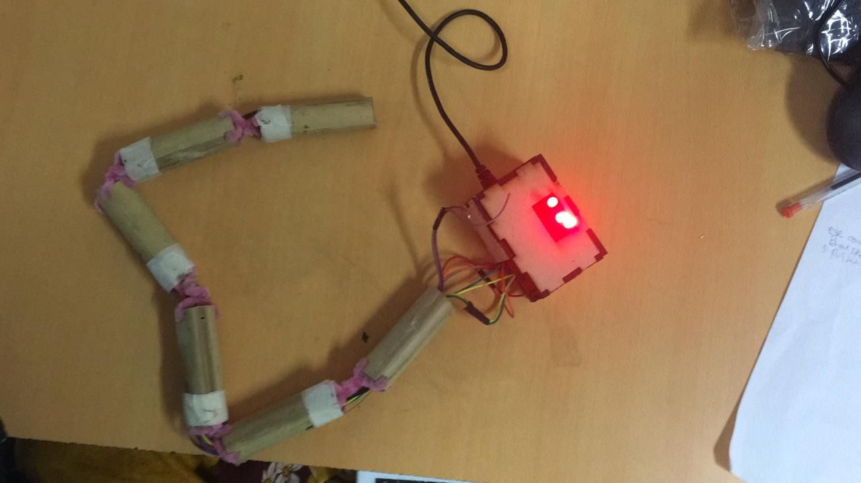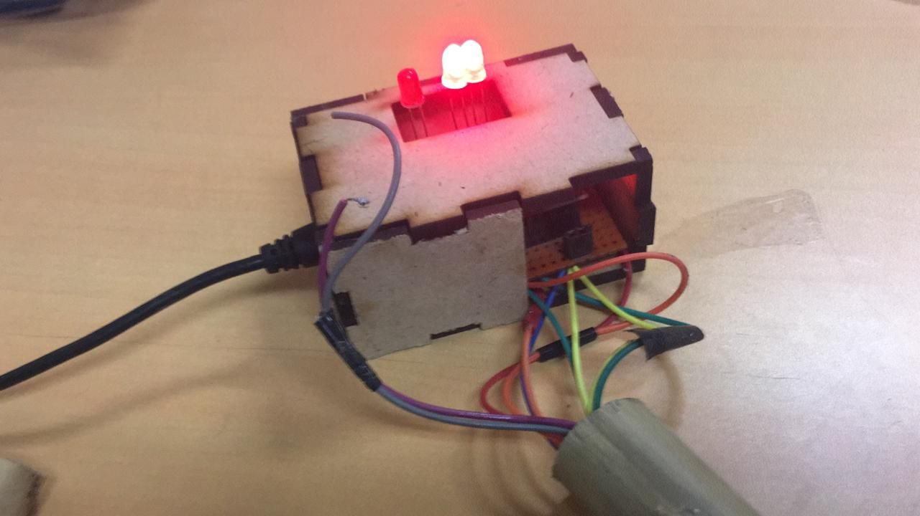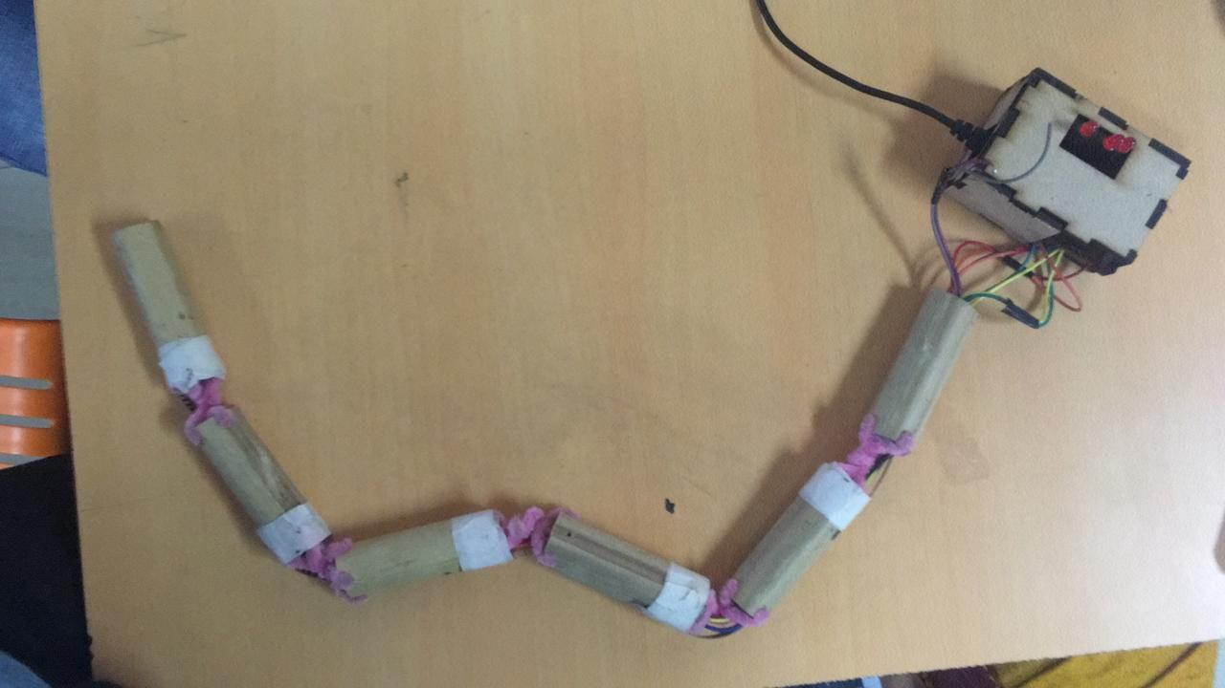

## Business Model Canvas

Scale up plan of the solution and basic financial modelling

## Story Telling/Communication narrative

Communication tools to tell your solutions story

## Jury review

Key learnings and feedback received from jury members.

## Takeaway

Why did you learn and would recommend for next teams?

## Reference

Links and resources used in the project.